### UE20CS301

## Database Management System

## Lab Quiz Set 1

Name : Renita Kurian

SRN : PES1UG20CS331

Roll No. : 13

Show tables:

## 

# Set 1

## Questions:

1.Write a trigger to prevent the insertion of a patient belonging to the locality ‘Devanahalli’ into the Patient table suggesting that this area is not serviceable.

DELIMITER $$

CREATE TRIGGER devanahalliPatient

BEFORE insert

ON Patient_331 for each ROW

BEGIN

DECLARE error_msg VARCHAR(255);

SET error_msg = ('Area not servicable');

IF new.locality='Devanahalli' THEN

 SIGNAL SQLSTATE '45000'

 SET MESSAGE_TEXT = error_msg;

END IF;

END $$

DELIMITER ;

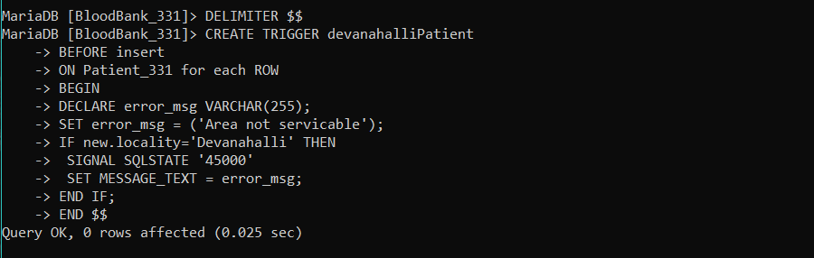



2. List the name and IDs of the patients who did not get the exact blood group as their own. Also display the blood group of blood unit and their actual blood group.

select patient_name, patient_id, P.blood_group, R.blood_group from (Patient_331 as P Natural JOIN Patient_Request_331 as X)JOIN Requests_331 as R ON R.request_id = X.request_id where R.blood_group!=P.blood_group;

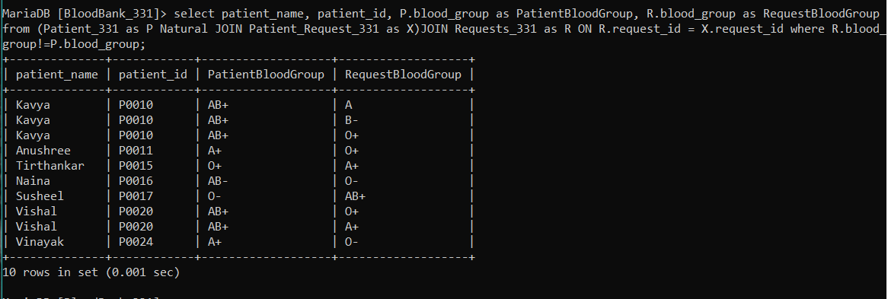

3. Write a function to set the health status of a donor. If the donor has some associated disease set health status to ‘Fair’, otherwise to ‘Good.

DELIMITER $$

CREATE FUNCTION getHealthStatus(disease varchar(255))

RETURNS VARCHAR(50)

DETERMINISTIC

BEGIN

    DECLARE stat varchar(255);

    if (disease!='Nil' and disease!='NIL') THEN

        set stat = 'Fair';

    Else

        set stat='Good';

    END IF;

    return stat;

END; $$

DELIMITER ;

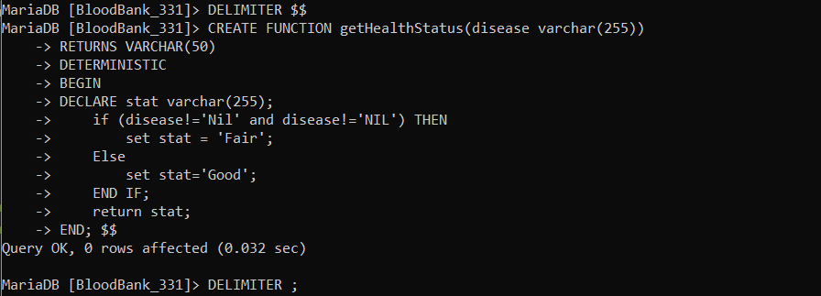

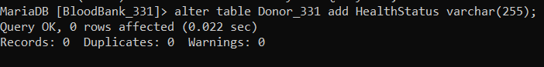

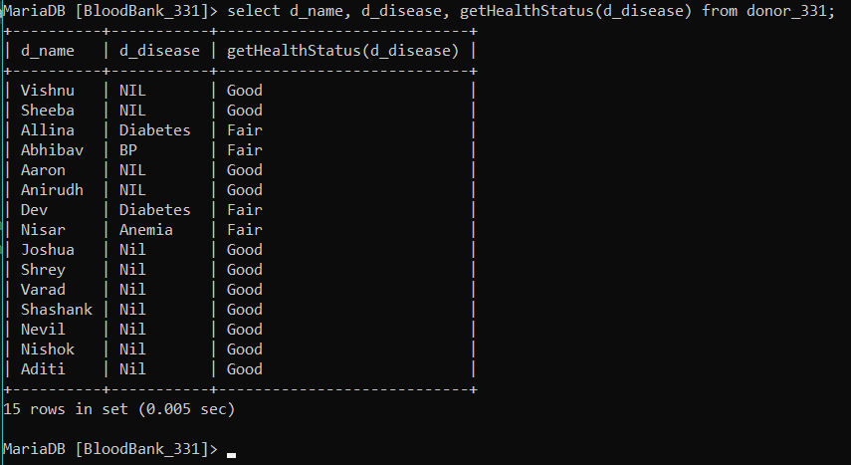

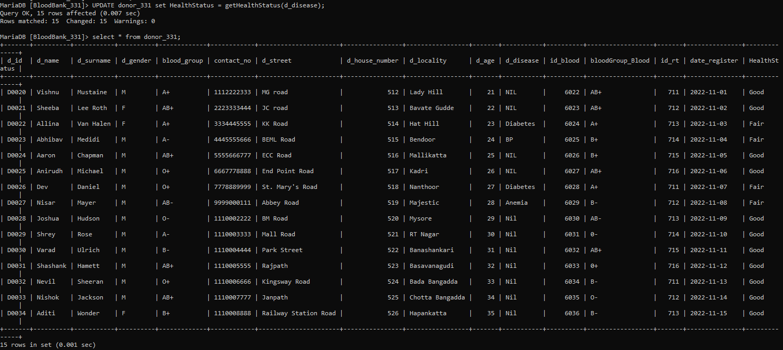

## SQL Exported File:

-- phpMyAdmin SQL Dump

-- version 5.1.1

-- https://www.phpmyadmin.net/

--

-- Host: 127.0.0.1

-- Generation Time: Nov 30, 2022 at 06:31 AM

-- Server version: 10.4.21-MariaDB

-- PHP Version: 8.0.10

SET SQL_MODE = "NO_AUTO_VALUE_ON_ZERO";

START TRANSACTION;

SET time_zone = "+00:00";

/*!40101 SET @OLD_CHARACTER_SET_CLIENT=@@CHARACTER_SET_CLIENT */;

/*!40101 SET @OLD_CHARACTER_SET_RESULTS=@@CHARACTER_SET_RESULTS */;

/*!40101 SET @OLD_COLLATION_CONNECTION=@@COLLATION_CONNECTION */;

/*!40101 SET NAMES utf8mb4 */;

--

-- Database: `bloodbank_331`

--

DELIMITER $$

--

-- Functions

--

CREATE DEFINER=`root`@`localhost` FUNCTION `getHealthStatus` (`disease` VARCHAR(255)) RETURNS VARCHAR(50) CHARSET utf8mb4 BEGIN

DECLARE stat varchar(255);

    if (disease!='Nil' and disease!='NIL') THEN

        set stat = 'Fair';

    Else

        set stat='Good';

    END IF;

    return stat;

END$$

DELIMITER ;

-- --------------------------------------------------------

--

-- Table structure for table `blood_bank_331`

--

CREATE TABLE `blood_bank_331` (

  `bb_id` int(4) NOT NULL,

  `bb_name` varchar(30) NOT NULL,

  `bb_street` varchar(50) NOT NULL,

  `bb_building_no` int(4) NOT NULL,

  `bb_locality` varchar(25) NOT NULL

) ENGINE=InnoDB DEFAULT CHARSET=utf8mb4;

--

-- Dumping data for table `blood_bank_331`

--

INSERT INTO `blood_bank_331` (`bb_id`, `bb_name`, `bb_street`, `bb_building_no`, `bb_locality`) VALUES

(1000, 'Red Cross Blood Bank', 'MG Road', 121, 'Central Bangalore'),

(1001, 'Rotary Blood Bank', 'Brigade Road', 201, 'North Bangalore'),

(1002, 'Lion\'s Blood Bank', 'Turahalli Road', 324, 'South Bangalore'),

(1003, 'Minerva Blood Bank', 'ECC Road', 444, 'East Banagalore');

-- --------------------------------------------------------

--

-- Table structure for table `blood_patient_331`

--

CREATE TABLE `blood_patient_331` (

  `bu_id` varchar(4) NOT NULL,

  `patient_id` varchar(5) NOT NULL,

  `blood_group` varchar(4) NOT NULL

) ENGINE=InnoDB DEFAULT CHARSET=utf8mb4;

--

-- Dumping data for table `blood_patient_331`

--

INSERT INTO `blood_patient_331` (`bu_id`, `patient_id`, `blood_group`) VALUES

('120', 'P0010', 'AB+'),

('120', 'P0014', 'O+'),

('117', 'P0016', 'O-'),

('111', 'P0024', 'A+'),

('120', 'P0024', 'O+'),

('119', 'P0020', 'AB+'),

('118', 'P0018', 'O-'),

('116', 'P0019', 'B-');

-- --------------------------------------------------------

--

-- Table structure for table `blood_units_331`

--

CREATE TABLE `blood_units_331` (

  `bu_id` varchar(4) NOT NULL,

  `blood_group` varchar(4) NOT NULL,

  `bb_id` int(4) NOT NULL

) ENGINE=InnoDB DEFAULT CHARSET=utf8mb4;

--

-- Dumping data for table `blood_units_331`

--

INSERT INTO `blood_units_331` (`bu_id`, `blood_group`, `bb_id`) VALUES

('111', 'A+', 1000),

('112', 'A-', 1000),

('113', 'B+', 1000),

('114', 'AB+', 1000),

('115', 'A+', 1001),

('116', 'B-', 1001),

('117', 'AB-', 1001),

('118', '0-', 1002),

('119', 'AB+', 1002),

('120', '0+', 1003),

('121', 'B-', 1003);

-- --------------------------------------------------------

--

-- Table structure for table `donor_331`

--

CREATE TABLE `donor_331` (

  `d_id` varchar(6) NOT NULL,

  `d_name` varchar(30) NOT NULL,

  `d_surname` varchar(30) NOT NULL,

  `d_gender` varchar(3) NOT NULL,

  `blood_group` varchar(4) NOT NULL,

  `contact_no` varchar(10) NOT NULL,

  `d_street` varchar(30) NOT NULL,

  `d_house_number` int(4) NOT NULL,

  `d_locality` varchar(20) NOT NULL,

  `d_age` int(2) NOT NULL,

  `d_disease` varchar(10) NOT NULL,

  `id_blood` int(4) NOT NULL,

  `bloodGroup_Blood` varchar(4) NOT NULL,

  `id_rt` int(4) NOT NULL,

  `date_register` date NOT NULL,

  `HealthStatus` varchar(255) DEFAULT NULL

) ENGINE=InnoDB DEFAULT CHARSET=utf8mb4;

--

-- Dumping data for table `donor_331`

--

INSERT INTO `donor_331` (`d_id`, `d_name`, `d_surname`, `d_gender`, `blood_group`, `contact_no`, `d_street`, `d_house_number`, `d_locality`, `d_age`, `d_disease`, `id_blood`, `bloodGroup_Blood`, `id_rt`, `date_register`, `HealthStatus`) VALUES

('D0020', 'Vishnu', 'Mustaine', 'M', 'A+', '1112222333', 'MG road', 512, 'Lady Hill', 21, 'NIL', 6022, 'AB+', 711, '2022-11-01', 'Good'),

('D0021', 'Sheeba', 'Lee Roth', 'F', 'AB+', '2223333444', 'JC road', 513, 'Bavate Gudde', 22, 'NIL', 6023, 'AB+', 712, '2022-11-02', 'Good'),

('D0022', 'Allina', 'Van Halen', 'F', 'A+', '3334445555', 'KK Road', 514, 'Hat Hill', 23, 'Diabetes', 6024, 'A+', 713, '2022-11-03', 'Fair'),

('D0023', 'Abhibav', 'Medidi', 'M', 'A-', '4445555666', 'BEML Road', 515, 'Bendoor', 24, 'BP', 6025, 'B+', 714, '2022-11-04', 'Fair'),

('D0024', 'Aaron', 'Chapman', 'M', 'AB+', '5555666777', 'ECC Road', 516, 'Mallikatta', 25, 'NIL', 6026, 'B+', 715, '2022-11-05', 'Good'),

('D0025', 'Anirudh', 'Michael', 'M', 'O+', '6667778888', 'End Point Road', 517, 'Kadri', 26, 'NIL', 6027, 'AB+', 716, '2022-11-06', 'Good'),

('D0026', 'Dev', 'Daniel', 'M', 'O+', '7778889999', 'St. Mary\'s Road', 518, 'Nanthoor', 27, 'Diabetes', 6028, 'A+', 711, '2022-11-07', 'Fair'),

('D0027', 'Nisar', 'Mayer', 'M', 'AB-', '9999000111', 'Abbey Road', 519, 'Majestic ', 28, 'Anemia', 6029, 'B-', 712, '2022-11-08', 'Fair'),

('D0028', 'Joshua', 'Hudson', 'M', 'O-', '1110002222', 'BM Road', 520, 'Mysore', 29, 'Nil', 6030, 'AB-', 713, '2022-11-09', 'Good'),

('D0029', 'Shrey', 'Rose', 'M', 'A-', '1110003333', 'Mall Road', 521, 'RT Nagar', 30, 'Nil', 6031, '0-', 714, '2022-11-10', 'Good'),

('D0030', 'Varad', 'Ulrich', 'M', 'B-', '1110004444', 'Park Street', 522, 'Banashankari', 31, 'Nil', 6032, 'AB+', 715, '2022-11-11', 'Good'),

('D0031', 'Shashank', 'Hamett', 'M', 'AB+', '1110005555', 'Rajpath', 523, 'Basavanagudi', 32, 'Nil', 6033, '0+', 716, '2022-11-12', 'Good'),

('D0032', 'Nevil', 'Sheeran', 'M', 'O+', '1110006666', 'Kingsway Road', 524, 'Bada Bangadda', 33, 'Nil', 6034, 'B-', 711, '2022-11-13', 'Good'),

('D0033', 'Nishok', 'Jackson', 'M', 'AB+', '1110007777', 'Janpath', 525, 'Chotta Bangadda', 34, 'Nil', 6035, 'O-', 712, '2022-11-14', 'Good'),

('D0034', 'Aditi', 'Wonder', 'F', 'B+', '1110008888', 'Railway Station Road', 526, 'Hapankatta', 35, 'Nil', 6036, 'B-', 713, '2022-11-15', 'Good');

-- --------------------------------------------------------

--

-- Table structure for table `hospital_331`

--

CREATE TABLE `hospital_331` (

  `hospital_id` varchar(4) NOT NULL,

  `h_name` varchar(20) NOT NULL,

  `h_street` varchar(20) NOT NULL,

  `h_building_no` int(3) NOT NULL,

  `h_locality` varchar(20) NOT NULL

) ENGINE=InnoDB DEFAULT CHARSET=utf8mb4;

--

-- Dumping data for table `hospital_331`

--

INSERT INTO `hospital_331` (`hospital_id`, `h_name`, `h_street`, `h_building_no`, `h_locality`) VALUES

('H030', 'Sri Sankara', 'Varthur Road', 123, 'KundanaHalli'),

('H031', 'RxDx', 'OR Road', 234, 'Benniganahalli'),

('H032', 'Apollo', 'MayFlower Avenue', 567, 'Jayanagar'),

('H033', 'Sakra', 'Banyan Avenue', 666, 'HAL');

-- --------------------------------------------------------

--

-- Table structure for table `hospital_request_331`

--

CREATE TABLE `hospital_request_331` (

  `request_id` int(4) NOT NULL,

  `hospital_id` varchar(4) NOT NULL

) ENGINE=InnoDB DEFAULT CHARSET=utf8mb4;

--

-- Dumping data for table `hospital_request_331`

--

INSERT INTO `hospital_request_331` (`request_id`, `hospital_id`) VALUES

(2, 'H030'),

(4, 'H031'),

(6, 'H032'),

(8, 'H033'),

(10, 'H033'),

(12, 'H033'),

(14, 'H031'),

(16, 'H030'),

(18, 'H032');

-- --------------------------------------------------------

--

-- Table structure for table `patient_331`

--

CREATE TABLE `patient_331` (

  `patient_id` varchar(5) NOT NULL,

  `patient_name` varchar(30) NOT NULL,

  `patient_surname` varchar(30) NOT NULL,

  `gender` varchar(1) NOT NULL,

  `blood_group` varchar(4) NOT NULL,

  `contact` varchar(50) NOT NULL,

  `street` varchar(20) NOT NULL,

  `house_number` varchar(5) NOT NULL,

  `locality` varchar(20) NOT NULL,

  `rt_id` int(4) NOT NULL,

  `date_registration` date NOT NULL

) ENGINE=InnoDB DEFAULT CHARSET=utf8mb4;

--

-- Dumping data for table `patient_331`

--

INSERT INTO `patient_331` (`patient_id`, `patient_name`, `patient_surname`, `gender`, `blood_group`, `contact`, `street`, `house_number`, `locality`, `rt_id`, `date_registration`) VALUES

('P0010', 'Kavya ', 'Gandhi', 'F', 'AB+', '1122334455', 'MG road', '10', 'Majestic ', 440, '2022-11-01'),

('P0011', 'Anushree', 'Shetty', 'F', 'A+', '2233445566', 'JC road', '20', 'Mysore', 441, '2022-11-02'),

('P0012', 'Sweety', 'Sen', 'F', 'A-', '3344556677', 'KK Road', '30', 'RT Nagar', 441, '2022-11-03'),

('P0013', 'Rupa', 'Ganguli', 'F', 'AB+', '4455667788', 'BEML Road', '40', 'Banashankari', 442, '2022-11-04'),

('P0014', 'Sudarshana', 'Dhar', 'F', 'O+', '5566778899', 'ECC Road', '50', 'Basavanagudi', 443, '2022-11-05'),

('P0015', 'Tirthankar', 'Bhattacharyya', 'M', 'O+', '6677889900', 'End Point Road', '60', 'Bada Bangadda', 444, '2022-11-06'),

('P0016', 'Naina ', 'Saini', 'F', 'AB-', '7788990011', 'St. Mary\'s Road', '70', 'Chotta Bangadda', 443, '2022-11-07'),

('P0017', 'Susheel', 'Sharma', 'M', 'O-', '8899001122', 'Abbey Road', '80', 'Hapankatta', 441, '2022-11-08'),

('P0018', 'Pakhi', 'Shah', 'F', 'A-', '9900112233', 'BM Road', '90', 'Lady Hill', 440, '2022-11-09'),

('P0019', 'Virat', 'Modi', 'M', 'B-', '1100223344', 'Mall Road', '11', 'Bavate Gudde', 442, '2022-11-10'),

('P0020', 'Vishal', 'Sharma', 'M', 'AB+', '2200113344', 'Park Street', '21', 'Hat Hill', 440, '2022-11-11'),

('P0021', 'Samar', 'Sen', 'M', 'O+', '1234512345', 'Rajpath', '31', 'Bendoor', 441, '2022-11-12'),

('P0022', 'Barkha', 'Dutt', 'F', 'AB+', '2345623456', 'Kingsway Road', '41', 'Mallikatta', 442, '2022-11-13'),

('P0023', 'Savi', 'Rao', 'F', 'B+', '4567845678', 'Janpath', '51', 'Kadri', 442, '2022-11-14'),

('P0024', 'Vinayak', 'Joshi', 'M', 'A+', '8899005566', 'Railway Station Road', '61', 'Nanthoor', 444, '2022-11-15'),

('P0032', 'Renita', 'Kurian', 'F', 'A+', '0981234561', 'AB Road', '12', 'Whitefield', 440, '2022-11-25');

--

-- Triggers `patient_331`

--

DELIMITER $$

CREATE TRIGGER `devanahalliPatient` BEFORE INSERT ON `patient_331` FOR EACH ROW BEGIN

DECLARE error_msg VARCHAR(255);

SET error_msg = ('Area not servicable');

IF new.locality='Devanahalli' THEN

 SIGNAL SQLSTATE '45000'

 SET MESSAGE_TEXT = error_msg;

END IF;

END

$$

DELIMITER ;

-- --------------------------------------------------------

--

-- Table structure for table `patient_request_331`

--

CREATE TABLE `patient_request_331` (

  `patient_id` varchar(5) NOT NULL,

  `request_id` int(4) NOT NULL

) ENGINE=InnoDB DEFAULT CHARSET=utf8mb4;

--

-- Dumping data for table `patient_request_331`

--

INSERT INTO `patient_request_331` (`patient_id`, `request_id`) VALUES

('P0010', 1),

('P0010', 15),

('P0010', 17),

('P0011', 11),

('P0015', 3),

('P0016', 13),

('P0017', 5),

('P0020', 7),

('P0020', 19),

('P0024', 9);

-- --------------------------------------------------------

--

-- Table structure for table `registeration_team_331`

--

CREATE TABLE `registeration_team_331` (

  `rt_member_id` int(4) NOT NULL,

  `rt_member_name` varchar(30) NOT NULL,

  `rt_member_surname` varchar(30) NOT NULL,

  `bb_id` int(4) NOT NULL

) ENGINE=InnoDB DEFAULT CHARSET=utf8mb4;

--

-- Dumping data for table `registeration_team_331`

--

INSERT INTO `registeration_team_331` (`rt_member_id`, `rt_member_name`, `rt_member_surname`, `bb_id`) VALUES

(440, 'Frieda', 'Slaves', 1000),

(441, 'Aravind', 'Govan', 1001),

(442, 'Vinod', 'Adesh', 1000),

(443, 'Arjun', 'Chand', 1001),

(444, 'Aarya', 'Chouhan', 1002),

(716, 'Ananya', 'Sequiera', 1003);

-- --------------------------------------------------------

--

-- Table structure for table `requests_331`

--

CREATE TABLE `requests_331` (

  `request_id` int(4) NOT NULL,

  `blood_group` varchar(4) NOT NULL,

  `units_of_blood` int(4) NOT NULL

) ENGINE=InnoDB DEFAULT CHARSET=utf8mb4;

--

-- Dumping data for table `requests_331`

--

INSERT INTO `requests_331` (`request_id`, `blood_group`, `units_of_blood`) VALUES

(1, 'A', 1),

(2, 'AB+', 2),

(3, 'A+', 3),

(4, 'A-', 4),

(5, 'AB+', 2),

(6, 'O+', 1),

(7, 'O+', 2),

(8, 'AB-', 1),

(9, 'O-', 1),

(10, 'O+', 2),

(11, 'O+', 1),

(12, 'AB-', 1),

(13, 'O-', 1),

(14, 'A-', 6),

(15, 'B-', 1),

(16, 'AB+', 1),

(17, 'O+', 1),

(18, 'AB+', 1),

(19, 'A+', 1);

-- --------------------------------------------------------

--

-- Table structure for table `technical_analysts_331`

--

CREATE TABLE `technical_analysts_331` (

  `ta_id` int(4) NOT NULL,

  `ta_name` varchar(30) NOT NULL,

  `ta_surname` varchar(30) NOT NULL,

  `bb_id` int(4) NOT NULL

) ENGINE=InnoDB DEFAULT CHARSET=utf8mb4;

--

-- Dumping data for table `technical_analysts_331`

--

INSERT INTO `technical_analysts_331` (`ta_id`, `ta_name`, `ta_surname`, `bb_id`) VALUES

(113, 'Vaidehi', 'Rogan', 1003),

(911, 'Varun', 'Vai', 1000),

(912, 'Sanjeeth', 'Gilbert', 1001),

(913, 'Sathish', 'Petrucci', 1002),

(914, 'Dev', 'Mustaine', 1003),

(915, 'Varshini', 'Friedman', 1002);

-- --------------------------------------------------------

--

-- Table structure for table `technical_analyst_blood_331`

--

CREATE TABLE `technical_analyst_blood_331` (

  `ta_id` int(4) NOT NULL,

  `bu_id` varchar(10) NOT NULL,

  `blood_group` varchar(4) NOT NULL

) ENGINE=InnoDB DEFAULT CHARSET=utf8mb4;

--

-- Dumping data for table `technical_analyst_blood_331`

--

INSERT INTO `technical_analyst_blood_331` (`ta_id`, `bu_id`, `blood_group`) VALUES

(113, '112', 'A-'),

(911, '113', 'B+'),

(912, '114', 'AB+'),

(913, '115', 'A+'),

(913, '116', 'B-'),

(912, '117', 'AB-'),

(914, '118', '0-'),

(915, '119', 'AB+'),

(113, '120', '0+'),

(911, '121', 'B-');

--

-- Indexes for dumped tables

--

--

-- Indexes for table `blood_bank_331`

--

ALTER TABLE `blood_bank_331`

  ADD PRIMARY KEY (`bb_id`);

--

-- Indexes for table `blood_patient_331`

--

ALTER TABLE `blood_patient_331`

  ADD KEY `bu_id` (`bu_id`);

--

-- Indexes for table `blood_units_331`

--

ALTER TABLE `blood_units_331`

  ADD PRIMARY KEY (`bu_id`),

  ADD KEY `bb_id` (`bb_id`);

--

-- Indexes for table `donor_331`

--

ALTER TABLE `donor_331`

  ADD PRIMARY KEY (`d_id`);

--

-- Indexes for table `hospital_331`

--

ALTER TABLE `hospital_331`

  ADD PRIMARY KEY (`hospital_id`);

--

-- Indexes for table `hospital_request_331`

--

ALTER TABLE `hospital_request_331`

  ADD PRIMARY KEY (`request_id`,`hospital_id`),

  ADD KEY `hospital_id` (`hospital_id`);

--

-- Indexes for table `patient_331`

--

ALTER TABLE `patient_331`

  ADD PRIMARY KEY (`patient_id`),

  ADD KEY `rt_id` (`rt_id`);

--

-- Indexes for table `patient_request_331`

--

ALTER TABLE `patient_request_331`

  ADD PRIMARY KEY (`patient_id`,`request_id`),

  ADD KEY `request_id` (`request_id`);

--

-- Indexes for table `registeration_team_331`

--

ALTER TABLE `registeration_team_331`

  ADD PRIMARY KEY (`rt_member_id`),

  ADD KEY `fk_bb_rt` (`bb_id`);

--

-- Indexes for table `requests_331`

--

ALTER TABLE `requests_331`

  ADD PRIMARY KEY (`request_id`);

--

-- Indexes for table `technical_analysts_331`

--

ALTER TABLE `technical_analysts_331`

  ADD PRIMARY KEY (`ta_id`),

  ADD KEY `fk_bb_ta` (`bb_id`);

--

-- Indexes for table `technical_analyst_blood_331`

--

ALTER TABLE `technical_analyst_blood_331`

  ADD KEY `bu_id` (`bu_id`),

  ADD KEY `ta_id` (`ta_id`);

--

-- Constraints for dumped tables

--

--

-- Constraints for table `blood_patient_331`

--

ALTER TABLE `blood_patient_331`

  ADD CONSTRAINT `blood_patient_ibfk_1` FOREIGN KEY (`bu_id`) REFERENCES `blood_units_331` (`bu_id`);

--

-- Constraints for table `blood_units_331`

--

ALTER TABLE `blood_units_331`

  ADD CONSTRAINT `blood_units_ibfk_1` FOREIGN KEY (`bb_id`) REFERENCES `blood_bank_331` (`bb_id`);

--

-- Constraints for table `hospital_request_331`

--

ALTER TABLE `hospital_request_331`

  ADD CONSTRAINT `hospital_request_ibfk_1` FOREIGN KEY (`hospital_id`) REFERENCES `hospital_331` (`hospital_id`),

  ADD CONSTRAINT `hospital_request_ibfk_2` FOREIGN KEY (`request_id`) REFERENCES `requests_331` (`request_id`);

--

-- Constraints for table `patient_331`

--

ALTER TABLE `patient_331`

  ADD CONSTRAINT `patient_ibfk_1` FOREIGN KEY (`rt_id`) REFERENCES `registeration_team_331` (`rt_member_id`);

--

-- Constraints for table `patient_request_331`

--

ALTER TABLE `patient_request_331`

  ADD CONSTRAINT `patient_request_ibfk_1` FOREIGN KEY (`request_id`) REFERENCES `requests_331` (`request_id`),

  ADD CONSTRAINT `patient_request_ibfk_2` FOREIGN KEY (`patient_id`) REFERENCES `patient_331` (`patient_id`),

  ADD CONSTRAINT `patient_request_ibfk_3` FOREIGN KEY (`patient_id`) REFERENCES `patient_331` (`patient_id`);

--

-- Constraints for table `registeration_team_331`

--

ALTER TABLE `registeration_team_331`

  ADD CONSTRAINT `fk_bb_rt` FOREIGN KEY (`bb_id`) REFERENCES `blood_bank_331` (`bb_id`);

--

-- Constraints for table `technical_analysts_331`

--

ALTER TABLE `technical_analysts_331`

  ADD CONSTRAINT `fk_bb_ta` FOREIGN KEY (`bb_id`) REFERENCES `blood_bank_331` (`bb_id`);

--

-- Constraints for table `technical_analyst_blood_331`

--

ALTER TABLE `technical_analyst_blood_331`

  ADD CONSTRAINT `technical_analyst_blood_ibfk_1` FOREIGN KEY (`bu_id`) REFERENCES `blood_units_331` (`bu_id`),

  ADD CONSTRAINT `technical_analyst_blood_ibfk_2` FOREIGN KEY (`ta_id`) REFERENCES `technical_analysts_331` (`ta_id`);

COMMIT;

/*!40101 SET CHARACTER_SET_CLIENT=@OLD_CHARACTER_SET_CLIENT */;

/*!40101 SET CHARACTER_SET_RESULTS=@OLD_CHARACTER_SET_RESULTS */;

/*!40101 SET COLLATION_CONNECTION=@OLD_COLLATION_CONNECTION */;